**CSE 5351 - Assignment 3**

Task 1

1. Blocking

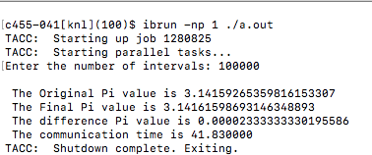

1. Non blocking

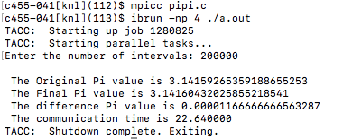

c)

Blocking efficiency

Non-blocking efficiency

Task 2

1. Broadcast

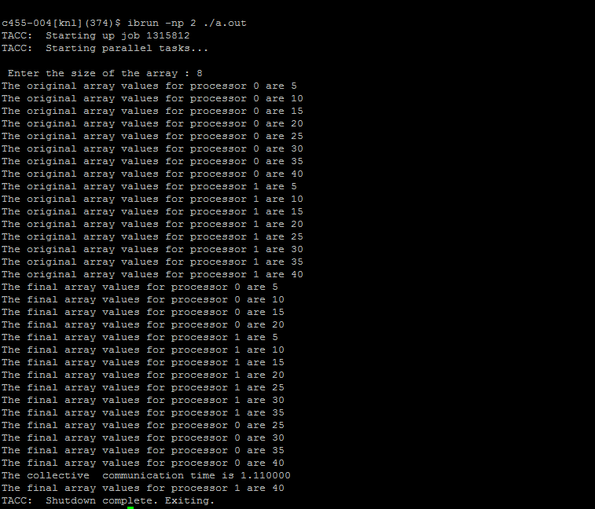

1. All to all

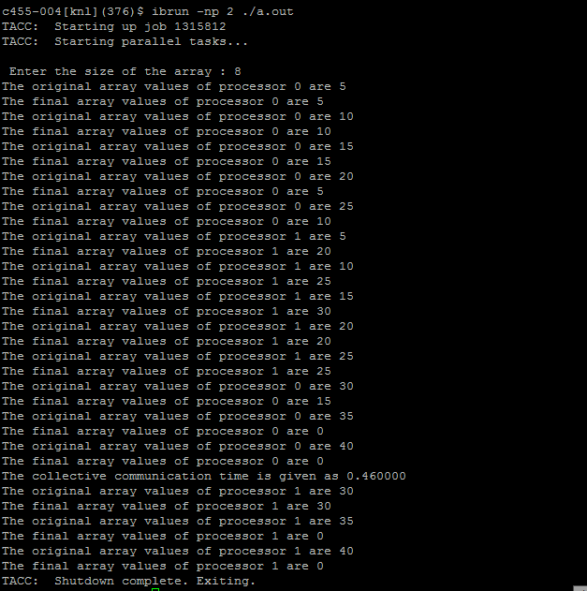

References

1. <http://www.math-cs.gordon.edu/courses/cps343/presentations/MPI_Collective.pdf>
2. <http://ranger.uta.edu/~iahmad/lectures/Part3.pdf>
3. <http://ranger.uta.edu/~iahmad/lectures/Part4.pdf>
4. <http://www.dailyfreecode.com/code/simpsons-13-rule-2390.aspx>
5. <https://www.mpich.org/static/docs/v3.1/www3/MPI_Ibcast.html>
6. <https://www.mpich.org/static/docs/v3.2/www3/MPI_Ireduce.html>
7. <https://linux.die.net/man/2/gettimeofday>
8. <http://mpi.deino.net/mpi_functions/MPI_Alltoall.html>
9. <https://www.mpich.org/static/docs/v3.1/www3/MPI_Alltoall.html>
10. <http://mpitutorial.com/tutorials/mpi-broadcast-and-collective-communication/>
11. <http://hpc.mines.edu/examples/examples/mpi/index.html>
12. <https://www.mpich.org/static/docs/v3.1/www3/MPI_Bcast.html>
13. <https://www.mpich.org/static/docs/v3.1/www3/MPI_Reduce.html>
14. <http://mpitutorial.com/tutorials/mpi-reduce-and-allreduce/>